- Software for Biblical Studies Review

Copyright © 2014 by Roger McCay

It seems to me that one of the best reasons for the existence of computers is the Biblical software that is on the market.

Really, when you consider the weight of Biblical study, it is a true advantage in speed of access and sheer volume of information to have at ones fingertips a computer loaded with software containing the Greek, Hebrew, and Aramaic texts of the Bible, multiple Biblical translations, multiple lexicons, dictionaries, and grammars, along with thousands of books, journals, documents, Bible studies, and sermons – basically a sizeable chunk of the corpus written on theology, the Bible, and related works from writers across several millennia that are all easily searchable and linked together for cross reference. Such a library combined with a good word processor … Well, Biblical scholarship now has capabilities that our fathers never dreamed‼

Such a digital library and research tool is something that anyone with a computer and some cash can purchase and use every single day in their own personal or professional studies – whatever your level of study might be.

There are four main programs that I’ve used over the years: Logos, Accordance, Bibleworks and Quickverse. I mostly use the first two, so I only review those in detail in this write-up.

This write-up also is by no means complete in reviewing every feature, etc. It is mostly how I use the programs along with particular aspects that have been very helpful to me. Hopefully, from this you can get an idea of how these can be of great benefit to you.

*** Warning: If you are a seminary student I strongly recommend that you wait until you have finished both Greek and Hebrew grammar and Greek and Exegesis and Hebrew and Exegesis before you consider purchasing or using one of these programs. You need to learn the languages the old fashioned hard way before using these. Otherwise you will stunt your knowledge – like initially learning how to walk while using crutches.

- The last version of Bibleworks I used was version 6.0, so I cannot really tell you a whole lot about the newer versions (currently version 9). I’ve replaced Bibleworks with Accordance in my regular use. I have no complaints with Bibleworks. It is just that once I transferred over to using a Mac I dumped Windows only programs for the most part. I recommend you look at their website for more info.

- Same deal for Quickverse as Bibleworks. It’s a Windows program - website. I still have a copy of Quickverse 2009 maxed out on resources, and sometimes I use it with Parallels on my Mac. But, it runs pretty slow and crashes often on me. The crashing and slowness may be a Parallels issue or just the program, but there it is. Anyway, I’ve phased Quickverse out of regular use and use Logos instead. Quickverse currently is on version 10, which seems to have really upped the ante since version 2009.

- These days I use Logos and Accordance throughout the week – mostly personal study and sermon prep (also for casual and pointed reading on my iPad). I typically have both programs open at the same time on my MacBook going back and forth between programs during serious study.

There are so many features for these programs it is best if you go to their websites for detailed information about them, but below I mention some of the particular features that I have found helpful in my studies.

- Logos is a massive tool for research and study – currently on version 5. Its great advantage, as I see it, is the sheer volume of works that Logos provides, which is constantly expanding. There are now more than 40,000 books available for Logos.

A particular feature that is helpful is the saved “layouts.” You can customize how the resources are laid out in your screen a number of ways. You can save multiple layouts (Accordance also has this feature). Examples of layouts I have put together in Logos include exegetical studies of various books of the Bible, commentary studies of various Biblical books, a multiple Bible comparison, a Pseudepigrapha study, and an ESV Study Bible layout. Below is an example of some current work I’ve been doing on my 13” MacBook, which is a set-up for an exegetical study on 1st Corinthians:

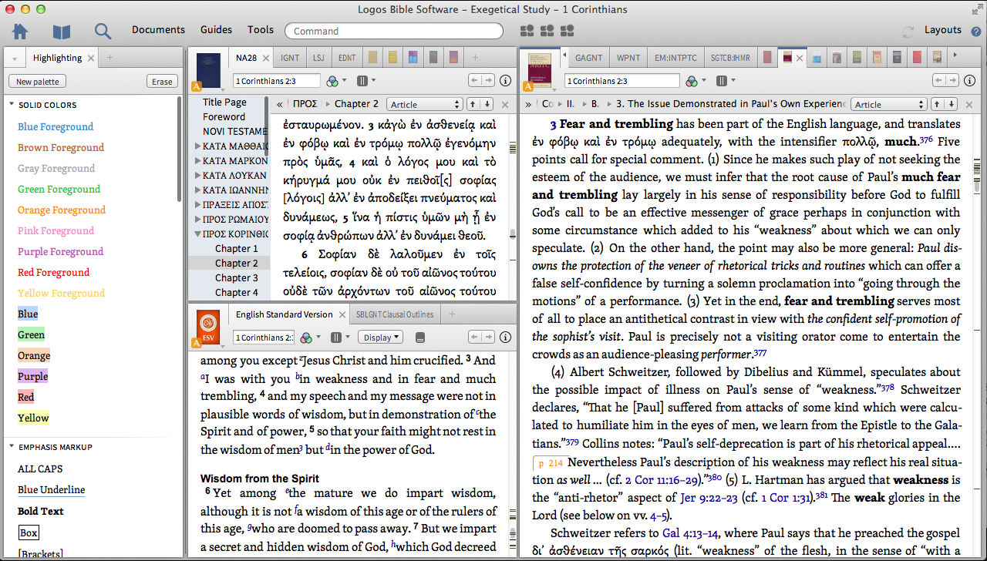

You’ll notice that in this layout one window has the NA28 version of the Greek New Testament opened with the ESV open in the window below it. On the left there is a window open with all the various highlighting functions. On the right the tab selected is a technical Greek Commentary: Anthony C Thiselton’s The First Epistle to the Corinthians: a Commentary on the Greek Text.

Note the tabs up top. Each tab is of a resource. Each resource can be linked. I.e. if you go to 1st Corinthians 2:5, all the resources set up along that reference system will go to that verse. So, as I click from tab to tab each will be opened to that verse.

Also, as I study/work, these resources change while I open and close various books, etc. when I follow certain “trails” and need to delve deeper into other resources in the library.

This particular window has the below resources open:

In the small screen with the NA28:

Aland, Kurt, Barbara Aland, Johannes Karavidopoulos, Carlo M. Martini, and Bruce M. Metzger. Novum Testamentum Graece. 28th Edition. [NA28] Stuttgart: Deutsche Bibelgesellschaft, 2012.

Porter, Stanley E. Idioms of the Greek New Testament. Sheffield: JSOT, 1999.

Liddell, Henry George, Robert Scott, Henry Stuart Jones, and Roderick McKenzie. A Greek-English Lexicon. Oxford: Clarendon Press, 1996.

Balz, Horst Robert, and Gerhard Schneider. Exegetical Dictionary of the New Testament. Grand Rapids, Mich.: Eerdmans, 1990.

Zerwick, Max. Biblical Greek Illustrated by Examples. English ed., adapted from the fourth Latin ed. Scripta Pontificii Instituti Biblici. Rome: Pontificio Istituto Biblico, 1963.

Robertson, A. T. A Grammar of the Greek New Testament in the Light of Historical Research. Logos Bible Software, 1919.

Kittel, Gerhard, Geoffrey W. Bromiley, and Gerhard Friedrich, eds. Theological Dictionary of the New Testament. Grand Rapids, MI: Eerdmans, 1964.

Spicq, Ceslas, and James D. Ernest. Theological Lexicon of the New Testament. Peabody, MA: Hendrickson Publishers, 1994.

Thayer, Joseph Henry. A Greek-English Lexicon of the New Testament: Being Grimm’s Wilke's Clavis Novi Testamenti. New York: Harper & Brothers, 1889.

The small window below that screen has the below two resources open:

The Holy Bible: English Standard Version. Wheaton: Standard Bible Society, 2001.

Deppe, Dean. The Lexham Clausal Outlines of the Greek New Testament: SBL Edition. Bellingham, WA: Lexham Press, 2011.

I also do my searches out of that window.

The large screen on the right has the following tabs of open books:

Zerwick, Max, and Mary Grosvenor. A Grammatical Analysis of the Greek New Testament. Rome: Biblical Institute Press, 1974.

Robertson, A.T. Word Pictures in the New Testament. Nashville, TN: Broadman Press, 1933.

Comfort, Philip. Encountering the Manuscripts: An Introduction to New Testament Paleography & Textual Criticism. Nashville, TN: Broadman & Holman, 2005.

Wegner, Paul D. A Student’s Guide to Textual Criticism of the Bible: Its History, Methods & Results. Downers Grove, IL: InterVarsity Press, 2006.

Metzger, Bruce Manning. A Textual Commentary on the Greek New Testament, Second Edition: a Companion Volume to the United Bible Societies’ Greek New Testament (4th Rev. Ed.). New York: United Bible Societies, 1994.

Thiselton, Anthony C. The First Epistle to the Corinthians: a Commentary on the Greek Text. New International Greek Testament Commentary. Grand Rapids, MI: W.B. Eerdmans, 2000.

Ciampa, Roy E., and Brian S. Rosner. The First Letter to the Corinthians. The Pillar New Testament Commentary. Grand Rapids, MI: William B. Eerdmans Publishing Company, 2010.

Hays, Richard B. First Corinthians. Interpretation, a Bible Commentary for Teaching and Preaching. Louisville, KY: John Knox Press, 1997.

Hodge, Charles. An Exposition of the First Epistle to the Corinthians. New York: Robert Carter & Brothers, 1857.

Prior, David. The Message of 1 Corinthians: Life in the Local Church. The Bible Speaks Today. Downers Grove, IL: InterVarsity Press, 1985.

Gaebelein, Frank E., Everett F. Harrison, W. Harold Mare, Murray J. Harris, and James Montgomery Boice. The Expositor’s Bible Commentary: Romans through Galatians. Vol. 10. Grand Rapids, MI: Zondervan Publishing House, 1976.

Lange, John Peter, Philip Schaff, Christian Friedrich Kling, and Daniel W. Poor. A Commentary on the Holy Scriptures: 1 Corinthians. Bellingham, WA: Logos Bible Software, 2008.

Calvin, John, and John Pringle. Commentaries on the Epistles of Paul the Apostle to the Corinthians. Bellingham, WA: Logos Bible Software, 2010.

All these resources are linked together and searchable. I have the option of searching just one of the open resources, all the open resources, all 2,299 books in my current Logos collection, and even custom collections that I put together along the lines of particular studies. There are dozens of types of searches that can be done. Further, with Logos (and Accordance) you can highlight, underline, bookmark, and write notes in all the books. You can also copy and paste selections into a word-processing program. Logos will also automatically footnote your selection in your document in the format you choose – i.e. Turabian, etc.

Another feature I’ve found nice to have is the personal books feature. Logos has the capability to add any Microsoft Word (.docx) document to its database. So, that means every sermon, paper, thesis, dissertation, Bible study note, or other work that you have on your computer that is in Word format can be linked into the database to be searched along with any search of the resources in Logos. This is very handy!

It is also helpful that Logos is a cross-platform application. You can use it on your iPad, iPhone, and your Mac. It can be used on Windows, and it can also be used on Android and Kindle.

I use the iPad app pretty regularly, and it can work like a Kindle. So, I pick a book and just read it on my iPad while bookmarking, highlighting, commenting, and sometimes selecting passages that I find notable and quotable sending them to my Macbook for use in sermons, etc.

Freebees – Logos is great about giving stuff away – click here. You can get free software for various platforms. Every month you can get a new book as part of the book of the month club. Also, you can download the entire Perseus Library of Classic Greek and Latin resources including grammars and lexicons (1,114 vols.); The Arabic Collection (37 vols.); The Civil War and 19th Century Collection (340 vols.); and the Renaissance Collection (22 vols.) among others.

Drawbacks to Logos – There are a few:
1) It is a memory hog. I’m not sure how this can be helped considering how much info just one book with all its tags takes up, much less 20 books or so opened all at once. So, as a memory hog it can slow your computer down. I maxed out the RAM on my computer (8 GB) just because of this one program, which is a cheap solution. With the expanded RAM it works just fine. The Logos website says that the minimum requirement for RAM is 2GB and 6+GB is recommended.
2) Sometimes Logos is a little slow coming out with certain promised resources. A current example is that I’ve been waiting for months for the Apparatus of the NA28 to come out that I paid for in advance. I had to go ahead and purchase it on Accordance, which quickly produced it once the new NA28 came out. I do use the hard copy of the NA28, but the quick search saves tons of time flipping back and forth.
3) Price. It is just plain expensive – but Accordance is not cheap either – see below. Base packages for Logos run from $159.95 for the Minimal cross-grade package ($110.00 higher than Accordance’s Starter package) and $294.95 for the Logos Starter package up to right under $5000 for the Portfolio package. Then, in addition to the base package you can spend several thousand dollars easily over time on sets of commentaries and other books that are available. The Logos folks compare their base package prices to the print prices saying you save lots of money with them. This seems true where base packages are concerned.
However, one thing that can be a little frustrating in this area is that when I want to buy a digital book, say a single book from a specific quality commentary, the Logos price is usually comparable to the print price. So, when I am looking for a book I compare the print price (Amazon, Abebooks, etc.) and the digital price (Logos) – then I buy whichever one is cheaper. Frankly, Logos would probably do better if every digital book they sell were always cheaper than the print price by a few dollars. They’d make more money from me that way, at least.
I currently have the Silver package (selling for $999.95 right now), but I started with a fairly inexpensive base package and upgraded here and there over the years up to this one (they discount your upgrades based on what you already own). The packages higher than this one just don’t appeal to me at this point. It seems better for me, now, to selectively buy books and collections on their own that fit my direction of study. There is more quality in the selective purchasing than in the bulk base packages anyway. You have to know what you are looking for and weigh the value of the base packages versus buying individually.

Here is a link to a comparison chart for their base packages – Logos Base Package Comparison
Here is a link for their videos telling all about what Logos can do – Logos Videos

Now, for the second program I have open while I study the Scriptures in depth – Accordance.

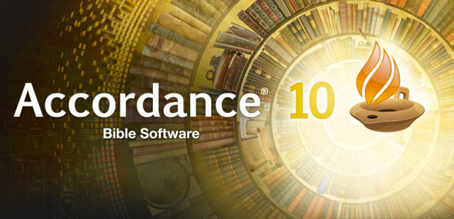

- Accordance has traditionally been a Mac only program, but they have now crossed over to Windows. The program is also cross platform and can be used on your iPad or iPhone.

Accordance is similar to Logos in that it has a fairly large database of books. However, it is much smaller than the Logos library.

Some choose to only use Logos for this reason. I have chosen to use both programs at the same time for the most part, however. I use Accordance mostly for translation purposes, and less for research. I use Logos heavily for research, and less for straight up translation – although the translation capabilities are comparable. I both translate and research while I study, hence working both programs at the same time. I will also open up Accordance rather than Logos for quick searches and such when I don’t need an in-depth study – it opens up much faster and goes straight to the point.

Perhaps the strongest aspect of Accordance, in my opinion, is its search function. It has a quick search function, but the best search features are done manually. Once you spend the time to figure out all the search commands and the various tricks, it is truly amazing what you can find. See their website for more info on this.

Accordance and Logos both have automatic parsing for the Greek and Hebrew – just run your mouse over the word you need to parse. I like the feature in Accordance where the information for the word comes up in a small window – giving the parsing, a definition, and Strong number.

I prefer Accordance for straight up translation help just because it is much more streamlined for this task. It doesn’t have all the “bulk” of Logos. Here is a screen shot of a recent study:

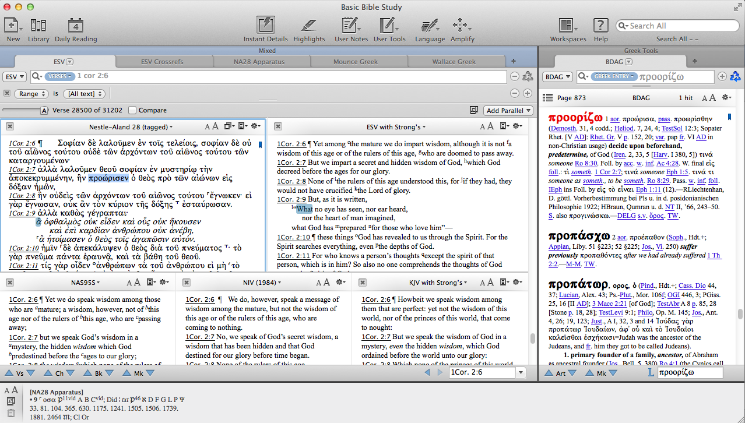

Accordance has a customizable desktop, so windows can be open, closed, rearranged, and such similar to Logos.

For this particular study the NA28 is open along with the ESV, NASB, and NIV (1984 version), and the KJV. They scroll together, and the versions linked to Strong’s each highlight the word(s) translated from the original language (which are often different in different versions) when you select a word in another version. The tagged NA28 or other similar tagged original language versions also highlight when you select a word in an English version tagged with Strong’s numbers.

Also, the dictionary is set-up on the right – the BDAG (A Greek - English Lexicon of the New Testament and other Early Christian Literature, Third Edition). You can switch back and forth between dictionaries by clicking the button that in this screenshot says “BDAG” at the top left of the widow. To select a word to look up, you just right click on the word in the Biblical text and choose to have the definition from a dictionary. The word with its definition then pops up in your preferred dictionary in the other window and you go from there. The BDAG is a worthwhile investment, as it is one of the best (if not the best, as I think) Greek lexicons. If you rely on base packages, the BDAG only comes in the “Ultimate” base package that costs $1999.99. So, unless you have the means to by the “Ultimate,” you will have to buy it separate.

There is a tab system in each window, similar to Logos. The tabs I’ve selected currently hold the NA28 Apparatus, The ESV cross-reference, Mounce’s Basics of Biblical Greek Grammar, and Wallace’s Greek Grammar beyond the Basics.

Notice that the NA28 Apparatus and ESV Crossrefs tabs are linked to the appropriate Bible in the first window. In the NA28 text, the textual notations are all hyperlinked to the appropriate place in the Apparatus, which is then hyperlinked to the appropriate reference explaining the note in the apparatus. This is very handy for those who take into consideration the texts and scholarship behind the critical text.

The bottom window shows the parsing info, or other info such as the note related to the notation letters you find in the ESV text, or the appropriate apparatus note as in the screenshot. You just move your cursor over the note.

For all the various features of Accordance I recommend checking their website. The program does much of what Logos does, but they are distinctly different in numerous ways. There are videos and tutorials that run you through what all Accordance can do – click here for their videos.

I have resisted buying too many resources for Accordance, and have stuck to the key lexicons, grammars, original texts, and various translations. This maintains the streamlined effect, and allows for it to work hand-in-hand with Logos.

For both programs I recommend starting with a small base package and then building from there. That way you can customize every aspect of your Biblical studies on the computer.

Pricing – Like Logos, a first class set-up of Accordance is not cheap. Base packages run from $49.99 up to $1999.99. Then, like Logos, you pay as you go as you add other books and such.

Here is a link to a comparison chart of their packages – Accordance Package Comparison

Freebees – Good luck with that. They do have a free trial demo, though – click here. Logos has them beat in the freebee area hands down.

Transfer license – If you buy the program on eBay or a friend gives you a copy this is important to know. The Accordance people charge a $25 fee if you give or sell your Accordance program with its library to another person. Logos has a $20 transfer fee. These fees seem to cover all of the automatic updates, account features and such that you get when you own the programs.

It is possible to use only Accordance without Logos, or vice-versa. However, there are times where one program has resources the other does not – like the NA28 Apparatus I mentioned earlier that Accordance has, and then the thousands of more resources Logos has than Accordance. Plus, each program has certain advantages over the other, which leads to certain folks to be die-hard for either one or the other program.

My solution is to use both.

However, if I could only purchase one program, I would purchase Logos.

I hope this has been a help to you!

